LAB 21 – Collaborative AI Coding: Pair Programming and Version Control Integration

NAME:J.SANJANA
ROLL-NO:2503A52379

TASK1:
Prompt given to AI:
"Generate a simple Python To-Do List Manager with options to add tasks, view tasks, delete tasks and exit. Then improve the program by adding error handling, input validation and a feature to mark tasks as completed.

Old Code:
tasks = []
while True:
print("\n===== TO-DO LIST MANAGER =====")
print("1. Add Task")
print("2. View Tasks")
print("3. Delete Task")
print("4. Exit")

choice = input("Enter your choice: ")

if choice == "1":
task = input("Enter task: ")
tasks.append(task)
print("Task added successfully!")

elif choice == "2":
for i, task in enumerate(tasks, start=1):
print(i, ".", task)

elif choice == "3":
task_no = int(input("Enter task number: "))
tasks.pop(task_no - 1)
print("Task deleted successfully!")

elif choice == "4":
break

else:
print("Invalid choice!")
IMPROVED CODE:
tasks = []

while True:
print("\n===== TO-DO LIST MANAGER =====")
print("1. Add Task")
print("2. View Tasks")
print("3. Delete Task")
print("4. Exit")

choice = input("Enter your choice: ")

if choice == "1":
task = input("Enter task: ")
tasks.append(task)
print("Task added successfully!")

elif choice == "2":
for i, task in enumerate(tasks, start=1):
print(i, ".", task)

elif choice == "3":
if tasks:
task_no = int(input("Enter task number: "))
if 1 <= task_no <= len(tasks):
tasks.pop(task_no - 1)
print("Task deleted successfully!")
else:
print("Invalid task number!")
else:
print("No tasks to delete!")

elif choice == "4":
break
print("Invalid choice!")
OUTPUT:
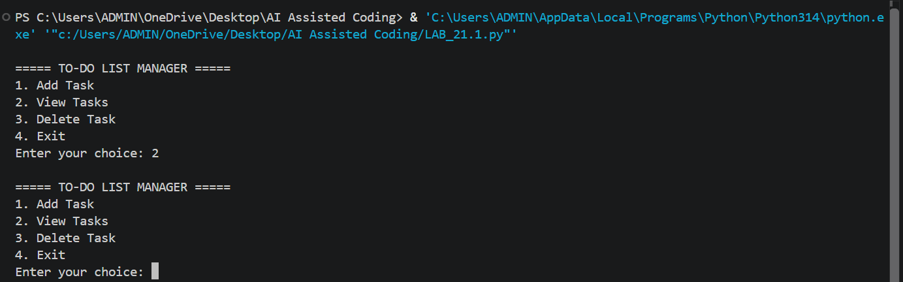
TASK2:
Prompt given to AI:
"Explain how to initialize a Git repository, create and switch to a new branch, add AI-assisted code modifications, commit changes with a meaningful message and merge the changes into the main branch. Provide the Git commands with explanations."

Old Code:
tasks = []

while True:
print("\n===== TO-DO LIST MANAGER =====")
print("1. Add Task")
print("2. View Tasks")
print("3. Delete Task")
print("4. Exit")

choice = input("Enter your choice: ")

if choice == "1":
task = input("Enter task: ")
tasks.append(task)
print("Task added successfully!")

elif choice == "2":
for i, task in enumerate(tasks, start=1):
print(i, ".", task)

elif choice == "3":
task_no = int(input("Enter task number: "))
tasks.pop(task_no - 1)
print("Task deleted successfully!")

elif choice == "4":
break

else:
print("Invalid choice!")
IMPROVED CODE:
tasks = []

def add_task():
task = input("Enter task: ").strip()

if task:
tasks.append({"name": task, "completed": False})
print("Task added successfully!")
else:
print("Task cannot be empty!")

def view_tasks():
if not tasks:
print("No tasks available!")
return

for i, task in enumerate(tasks, start=1):
status = "Completed" if task["completed"] else "Pending"
print(i, task["name"], "-", status)

def delete_task():
view_tasks()

if not tasks:
return

try:
n = int(input("Enter task number: "))

if 1 <= n <= len(tasks):
tasks.pop(n - 1)
print("Task deleted successfully!")
else:
print("Invalid task number!")

except ValueError:
print("Enter a valid number!")

def complete_task():
view_tasks()

if not tasks:
return

try:
n = int(input("Enter task number: "))

if 1 <= n <= len(tasks):
tasks[n-1]["completed"] = True
print("Task completed!")
else:
print("Invalid task number!")

except ValueError:
print("Enter a valid number!")

while True:
print("\n===== TO-DO LIST MANAGER =====")
print("1. Add Task")
print("2. View Tasks")
print("3. Delete Task")
print("4. Complete Task")
print("5. Exit")

choice = input("Enter choice: ")

if choice == "1":
add_task()
elif choice == "2":
view_tasks()
elif choice == "3":
delete_task()
elif choice == "4":
complete_task()
elif choice == "5":
break
else:
print("Invalid choice!")

OUTPUT:
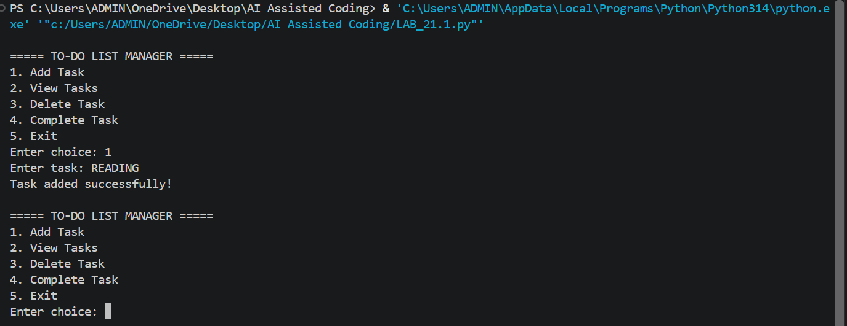
Git Commands: 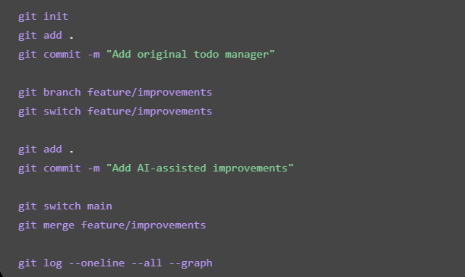

TASK3:
Prompt given to AI:
"Explain how to initialize a Git repository, create and switch to a new branch, add AI-assisted code modifications, commit changes with a meaningful message and merge the changes into the main branch. Provide the Git commands with explanations."

Old Code:
tasks = []

task = input("Enter task: ")
tasks.append(task)

print("Tasks:", tasks)

task_no = int(input("Enter task number to delete: "))
tasks.pop(task_no - 1)

print("Updated tasks:", tasks)

IMPROVED CODE:
tasks = []

def add_task():
task = input("Enter task: ").strip()

if task:
tasks.append({"name": task, "completed": False})
print("Task added")
else:
print("Task cannot be empty")

def view_tasks():
for i, task in enumerate(tasks, start=1):
status = "Completed" if task["completed"] else "Pending"
print(i, task["name"], "-", status)

def complete_task():
view_tasks()

try:
number = int(input("Enter task number: "))

if 1 <= number <= len(tasks):
tasks[number - 1]["completed"] = True
print("Task completed")
else:
print("Invalid task number")

except ValueError:
print("Enter a valid number")

add_task()
view_tasks()
complete_task()
view_tasks()
OUTPUT:
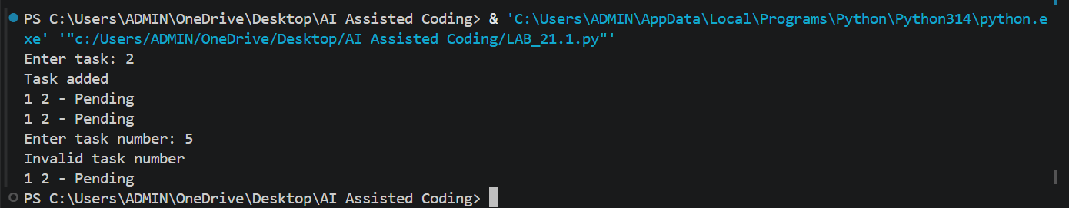
Git Commands:
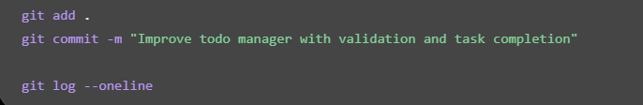
TASK4:
Prompt given to AI:
"Create a simple Python Calculator program. Student A writes the basic calculator with addition, subtraction, multiplication and division. Student B uses AI assistance to improve the program by adding input validation, error handling and better code organization using functions. Explain how both students can collaborate using Git branches and merging."

Old Code:
num1 = int(input("Enter first number: "))
num2 = int(input("Enter second number: "))

print("1. Addition")
print("2. Subtraction")
print("3. Multiplication")
print("4. Division")

choice = int(input("Enter choice: "))

if choice == 1:
print("Result:", num1 + num2)
elif choice == 2:
print("Result:", num1 - num2)
elif choice == 3:
print("Result:", num1 * num2)
elif choice == 4:
print("Result:", num1 / num2)
else:
print("Invalid choice")

IMPROVED CODE:
def calculator():
try:
num1 = float(input("Enter first number: "))
num2 = float(input("Enter second number: "))

print("\n1. Addition")
print("2. Subtraction")
print("3. Multiplication")
print("4. Division")

choice = input("Enter choice: ")

if choice == "1":
result = num1 + num2
elif choice == "2":
result = num1 - num2
elif choice == "3":
result = num1 * num2
elif choice == "4":
if num2 == 0:
print("Cannot divide by zero")
return
result = num1 / num2
else:
print("Invalid choice")
return

print("Result:", result)

except ValueError:
print("Please enter valid numbers")

calculator()

OUTPUT:
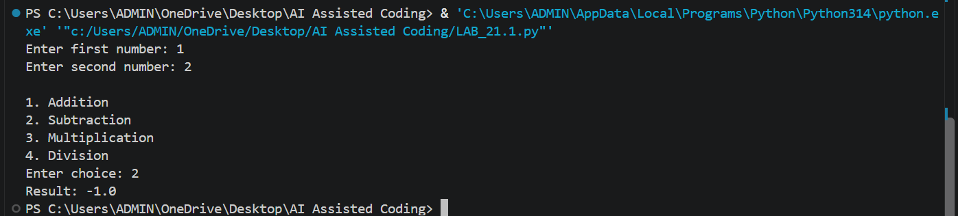
Git Commands: 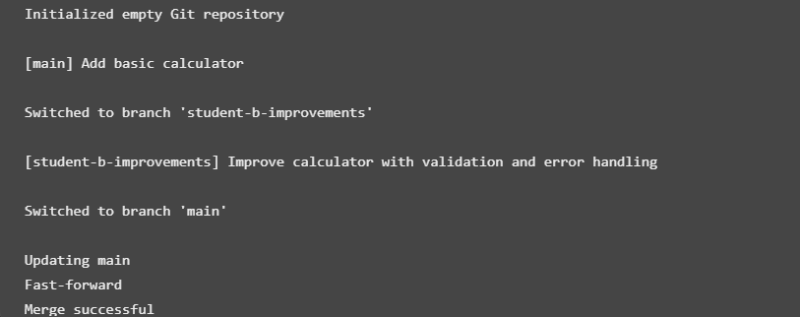
TASK5:
Prompt given to AI:
"Find and fix the syntax and logical errors in the following Python program. Explain the errors and provide the corrected code."

Old Code:
# Program to calculate the average of three numbers

num1 = input("Enter first number: ")
num2 = input("Enter second number: ")
num3 = input("Enter third number: ")

total = num1 + num2 + num3
average = total / 2

if average > 50
print("Pass")
else:
print("Fail")
IMPROVED CODE:
# Program to calculate the average of three numbers

try:
num1 = float(input("Enter first number: "))
num2 = float(input("Enter second number: "))
num3 = float(input("Enter third number: "))

total = num1 + num2 + num3
average = total / 3

print("Total:", total)
print("Average:", average)

if average >= 50:
print("Pass")
else:
print("Fail")

except ValueError:
print("Please enter valid numbers")

OUTPUT:
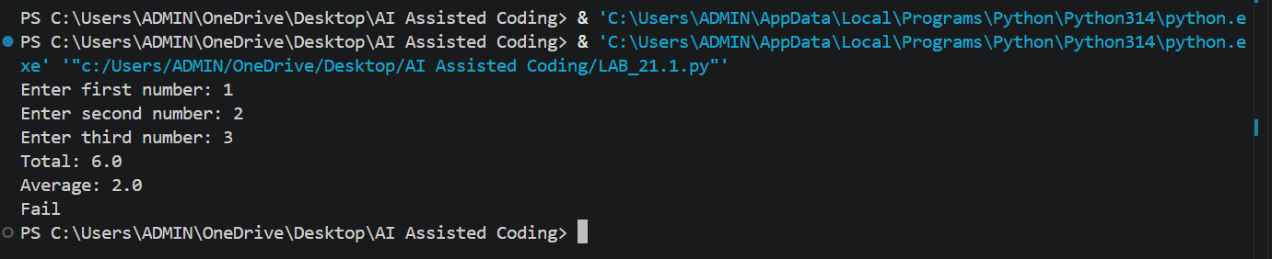
COMPARISION:
Buggy Version | Corrected Version
Missing colon after if | Added the missing colon
Used input() without converting to  numbers | Used float()
Calculated average by dividing by 2 | Corrected division to 3
No invalid-input handling | Added try-except
Incorrect pass condition (> 50) | Uses >= 50

TASK6:
Prompt given to AI:
"Create a basic Python calculator with addition, subtraction, multiplication and division. Use AI to improve it by adding calculation history, input validation, division-by-zero handling and better code organization."
Old Code:
num1 = float(input("Enter first number: "))
num2 = float(input("Enter second number: "))

print("1. Addition")
print("2. Subtraction")
print("3. Multiplication")
print("4. Division")

choice = int(input("Enter choice: "))

if choice == 1:
print("Result:", num1 + num2)
elif choice == 2:
print("Result:", num1 - num2)
elif choice == 3:
print("Result:", num1 * num2)
elif choice == 4:
print("Result:", num1 / num2)
else:
print("Invalid choice")
IMPROVED CODE:
history = []

def calculator():
try:
num1 = float(input("Enter first number: "))
num2 = float(input("Enter second number: "))

print("\n1. Addition")
print("2. Subtraction")
print("3. Multiplication")
print("4. Division")

choice = input("Enter choice: ")

if choice == "1":
result = num1 + num2
operator = "+"
elif choice == "2":
result = num1 - num2
operator = "-"
elif choice == "3":
result = num1 * num2
operator = "*"
elif choice == "4":
if num2 == 0:
print("Cannot divide by zero")
return
result = num1 / num2
operator = "/"
else:
print("Invalid choice")
return

print("Result:", result)
history.append(f"{num1} {operator} {num2} = {result}")

except ValueError:
print("Please enter valid numbers")

def show_history():
if not history:
print("No calculation history")
else:
print("\nCalculation History:")
for item in history:
print(item)

while True:
print("\n1. Calculate")
print("2. View History")
print("3. Exit")

choice = input("Enter choice: ")

if choice == "1":
calculator()
elif choice == "2":
show_history()
elif choice == "3":
print("Exiting calculator")
break
else:
print("Invalid choice")

OUTPUT:
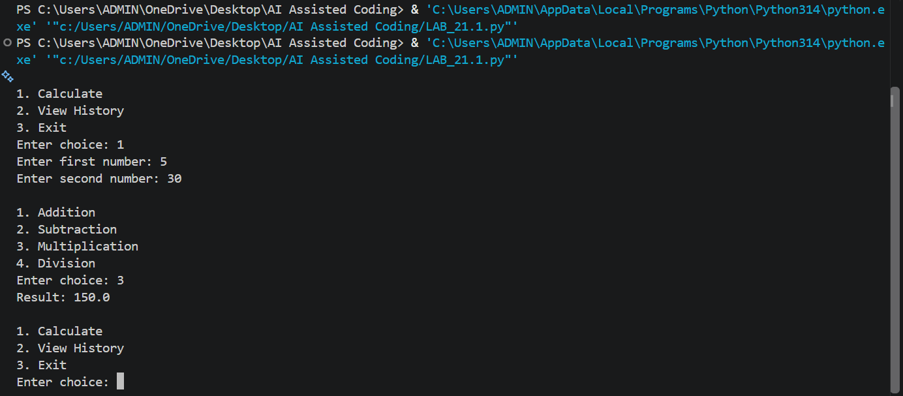

Analysis of Improvements
Basic Calculator | AI-Enhanced Calculator
Performs basic calculations | Performs calculations and stores history
No input validation | Handles invalid inputs
No division-by-zero protection | Prevents division by zero
No history feature | Displays previous calculations
Limited functionality | More user-friendly and reliable

